
GOLDFIELDS DIVISION
CROSS COUNTRY CHAMPIONSHIPS 2025

Friday 16th of May

Wesley Hill Recreation Area, Castlemaine

Organised by Bree Brown, Amy Cordy & Clare Grainger

FORMAT:

- Finals for students whose school is affiliated with School Sport Victoria
(Qualifiers established by individual school or District – including Multi-Class athletes who must hold a current classification. We do not need names or numbers prior to the event.)

- AGE calculated at 31st December this year. S

- The events will be organised approximately as follows:
(Multi-Class athletes will participate at the same time as their relevant age-group)

10:30 12/13 years Boys/Mixed 3km BLUE tag
11:00 12/13 years Girls 3km BLUE tag
11:30 11 years Boys/Mixed 3km RED tag
12:00 11 years Girls 3km RED tag
12:30 9/10 years Boys/Mixed 2km YELLOW tag
12:45 9/10 years Girls 2km YELLOW tag
Presentations for 1st, 2nd and 3rd will be conducted at the conclusion of each event

- FIRST AID – A first aid / sports trainer will be in attendance.

- ENTRY FEE - To cover expenses, students will be charged an entry fee of $5.00 each ($4.00 each if your school is a member of the Bendigo Phys. Ed. Committee). A tax invoice will be emailed after the event. All schools competing must be affiliated with School Sport Victoria.

- NAME TAGS - All children must wear a coloured name tag as specified above. This must be attached to the wrist with name, school and group marked on it – there is an example on the next page. Please circle Multi-Class if relevant.

- OFFICIALS - Each school must supply an official to report to a 10am briefing to assist with judging, recording, check points, etc. Please email brianna.brown@education.vic.gov.au in advance.

- MARSHALLING - The children will be called to the marshalling area approximately 10 minutes prior to each event.

- REGION - The first 12 finishers in each event will represent their Division at the Loddon Mallee Region Cross Country in St Arnaud on Tuesday 27th May.

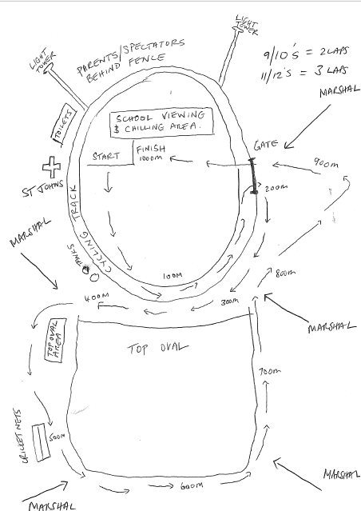

Goldfields Division Cross Country
Name:____________________________
School: __________________________
BOY / MIXED / GIRL
Multi-Class

Goldfields Division Cross Country
Name:_____________________________
School: ____________________________
BOY / MIXED / GIRL
Multi-Class

Goldfields Division Cross Country
Name:____________________________
School: __________________________
BOY / MIXED / GIRL
Multi-Class

Goldfields Division Cross Country
Name:_____________________________
School: ____________________________
BOY / MIXED / GIRL
Multi-Class

Goldfields Division Cross Country
Name:____________________________
School: __________________________
BOY / MIXED / GIRL
Multi-Class

Goldfields Division Cross Country
Name:_____________________________
School: ____________________________
BOY / MIXED / GIRL
Multi-Class

Goldfields Division Cross Country
Name:____________________________
School: __________________________
BOY / MIXED / GIRL
Multi-Class

Goldfields Division Cross Country
Name:_____________________________
School: ____________________________
BOY / MIXED / GIRL
Multi-Class

